INFO 2416 S11
Lab #1 : Installing Windows Server and Client on a Virtual Machine
Annze Julia Villena
100372699
Date Submission: September 24, 2020

Creat a host-only network
3. d. iii ) Host-Only DHCP Server settings
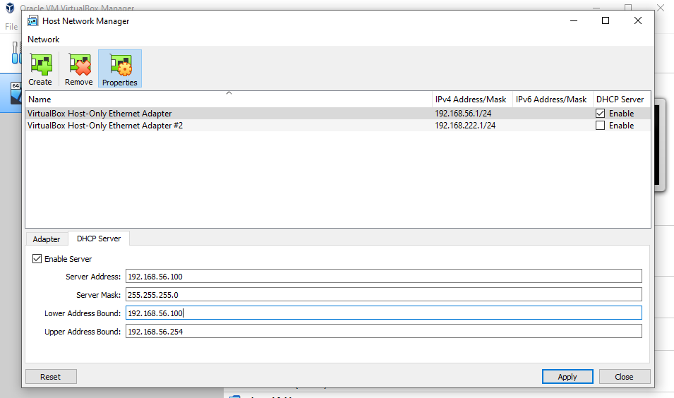

Create Windows 10 and Windows Server 2012 R2 VMs
4.a.vi) Windows Server VM and its hardware settings
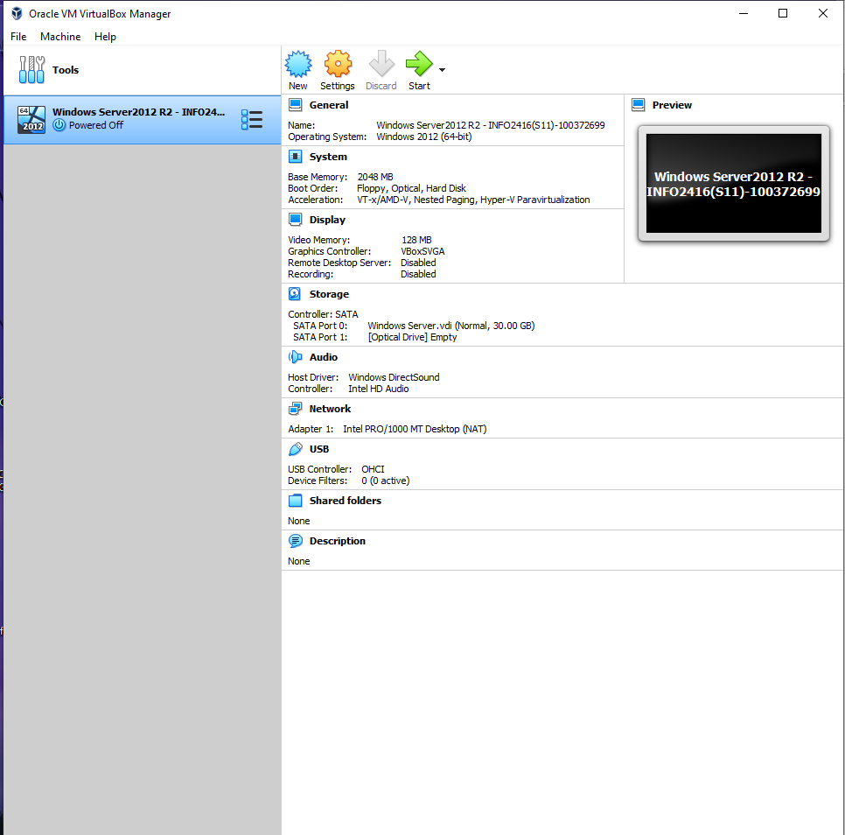

c) Windows Server 2012 VM start screen; Date and time displayed
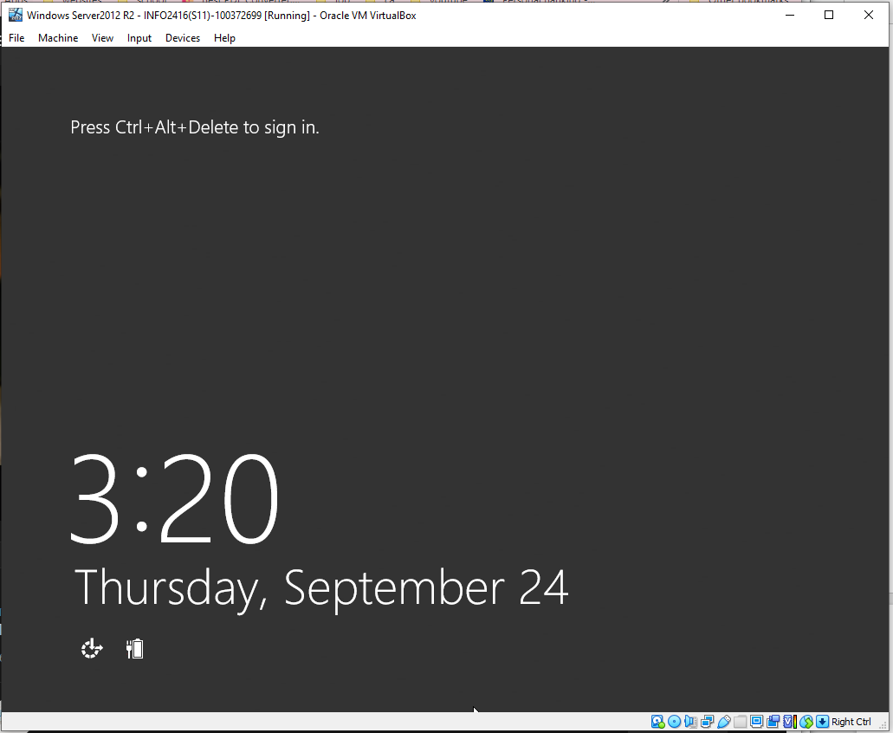

5.a.vi) Windows 10 VM and hardware settings; Date and Time (I had missed this screenshot in the earlier steps therefore took a screenshot after completing everything)
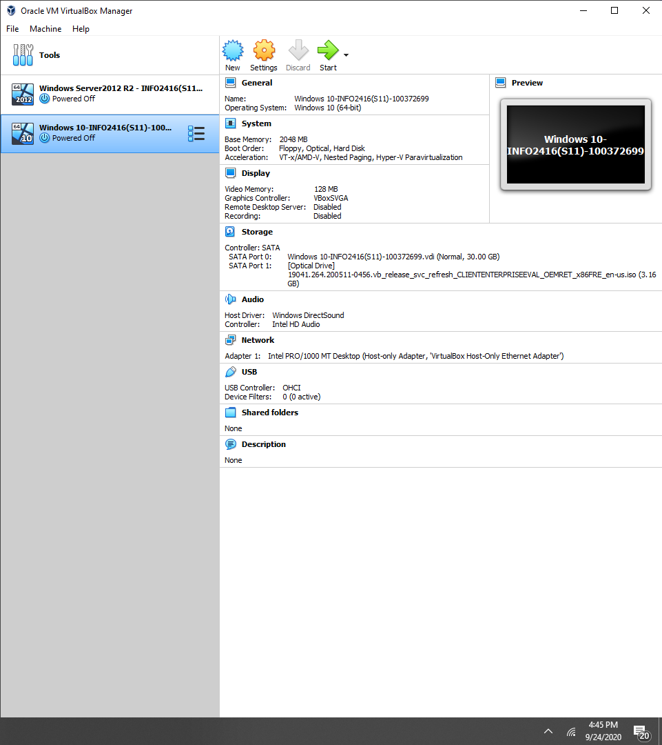
5.b.vi) Windows 10 VM desktop
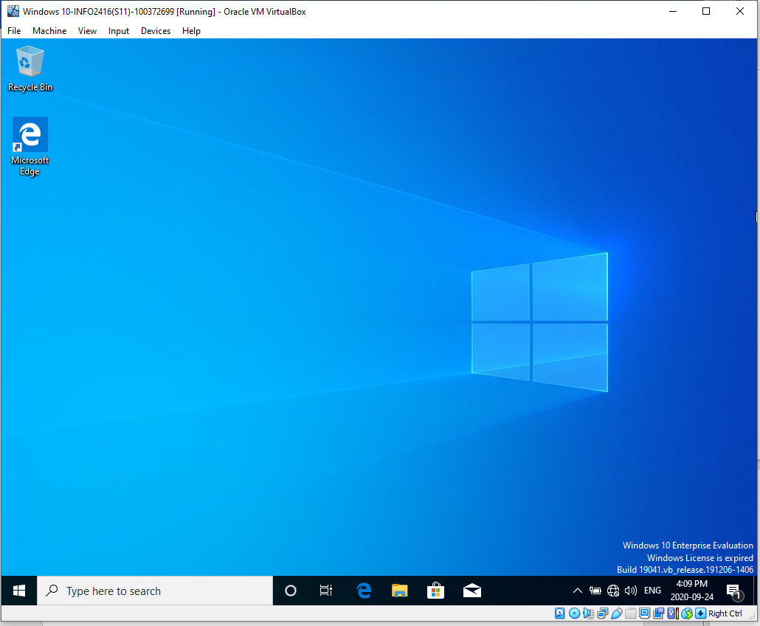
Demonstrate that two VMs can communicate
6.a.i) Windows Server R2 VM IPv4 settings
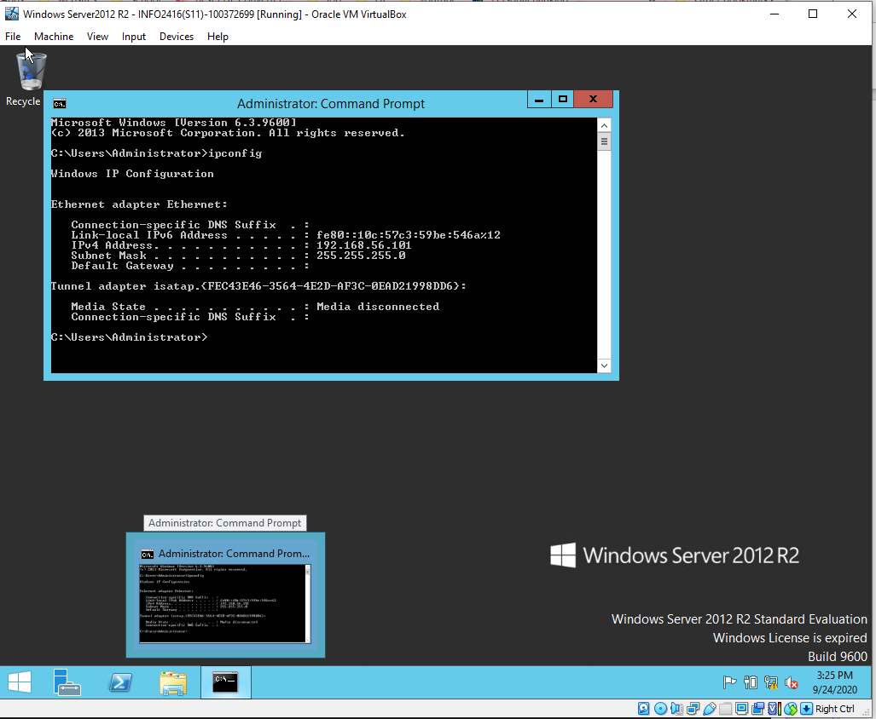

7.a.i) Windows 10 VM IPv4 settings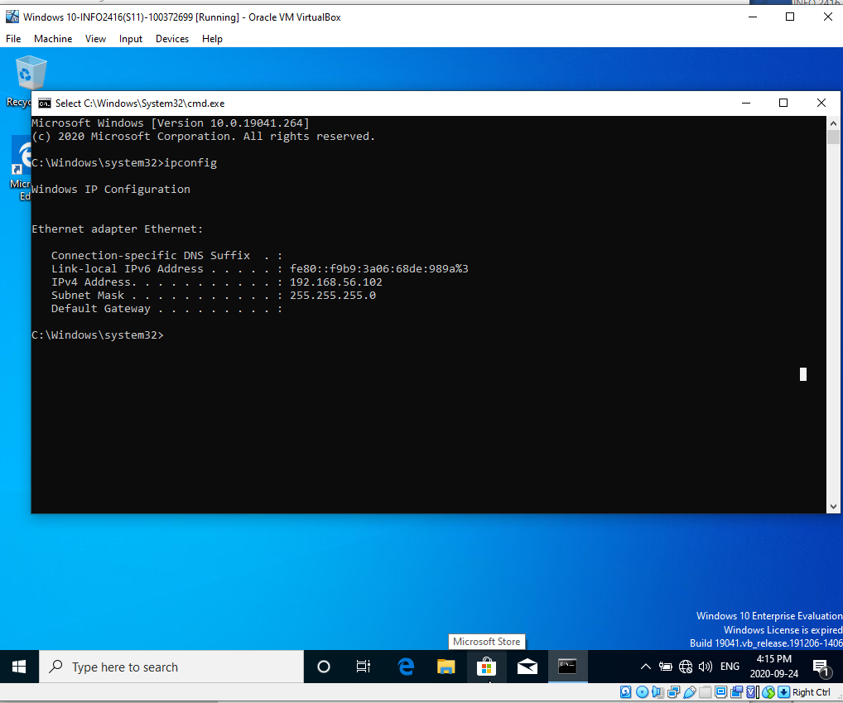9.b.iii) Windows 10 VM successful ping to Windows Server 2012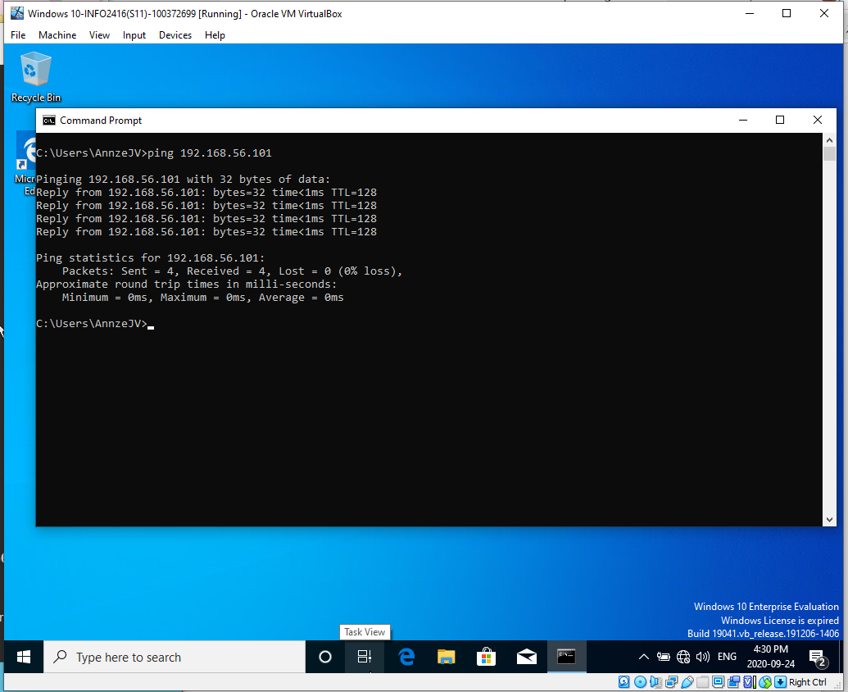
9.c.iii) Windows Server 2012 successful ping to Window 10